**Experiment - 1.4(c)**

**Student Name: Milan Sharma UID: 23MAI10003**

**Branch: ME – CSE - AIML Section/Group: MAI – 1 (A)**

**Semester: 1st Date of Performance: 29 Aug 2023**

**Subject Name: Python Programming Subject Code: 23 CSH 623**

1. **Aim of the Experiment :**

Write a python program to calculate factorial of a number

1. **Objective of the Experiment :**

To calculate factorial of a number

1. **Algorithm/ Steps for Experiment**

1.        Start

2.        Declare Variable n, fact, i

3.        Read number from User

4.        Initialize Variable fact=1 and i=1

5.        Repeat Until i<=number

6.        fact=fact*i

7.        i=i+1

8.        Print fact

9.        Stop

1. **Code for Experiment :**

num = int(input("Enter a number: "))

factorial = 1

if num < 0:

print("Sorry, factorial does not exist for negative numbers")

elif num == 0:

print("The factorial of 0 is 1")

else:

for i in range(1,num + 1):

factorial = factorial*i

print("The factorial of",num,"is",factorial)

1. **Result/Output :**

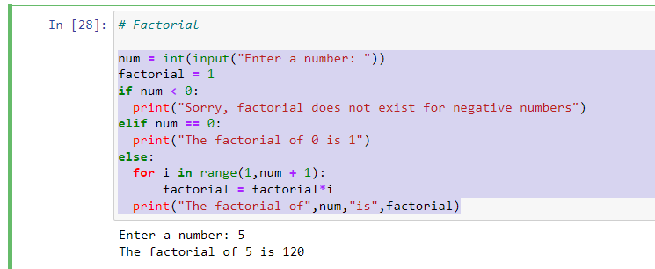

**Learning outcomes (What I have learnt):**

1. Learnt the use of range function.